IBM SMART INTERNZ – PROJECT BASED LEARNING 2022SMARTSOLUTIONFORRAILWAYS

**TEAM ID: PNT2022TMID15168**

TEAM MEMBERS: Jothikrishna K,Ashwin M, Kabil S, Mohamed Hanish A

**PROJECTOBJECTIVE:**

SmartSolutionsforrailwaysisdesignedtoreducedtheworkloadoftheuserandalsotheuse ofpaper.

# PROJECTFEATURES:

* AWebpageisdesignedforthepublicwheretheycanbookticketsbyseeingtheavailable seats.
* Afterbookingthetrain,thepersonwillgetaQRcodewhichhastobeshowntotheTicketCollectorwhileboardingthetrain.
* TheticketcollectorscanscantheQRcodetoidentifythepersonaldetails.
* AGPSmoduleispresentinthetraintotrackit.Thelivestatusofthejourneyisupdatedin theWeb appcontinuously
* AllthebookingdetailsofthecustomerswillbestoredinthedatabasewithauniqueIDandtheycan be retrievedbackwhentheTicket Collector scansthe QRCode

# TOOLSREQUIRED:

* Python
* IBMCloud
* Node-RED,
* IoTPlatform
* MITAppInventor
* IBMCloudantDB

# TECHNICALARCHITECTURE:

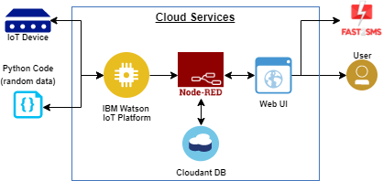

1. **Pythoncodeforsmartrailways:**

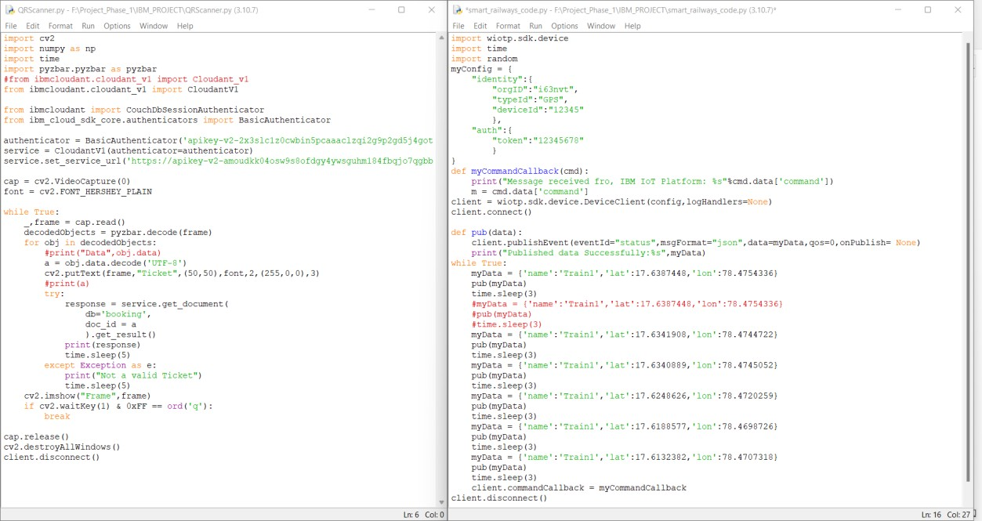

OUTPUT:

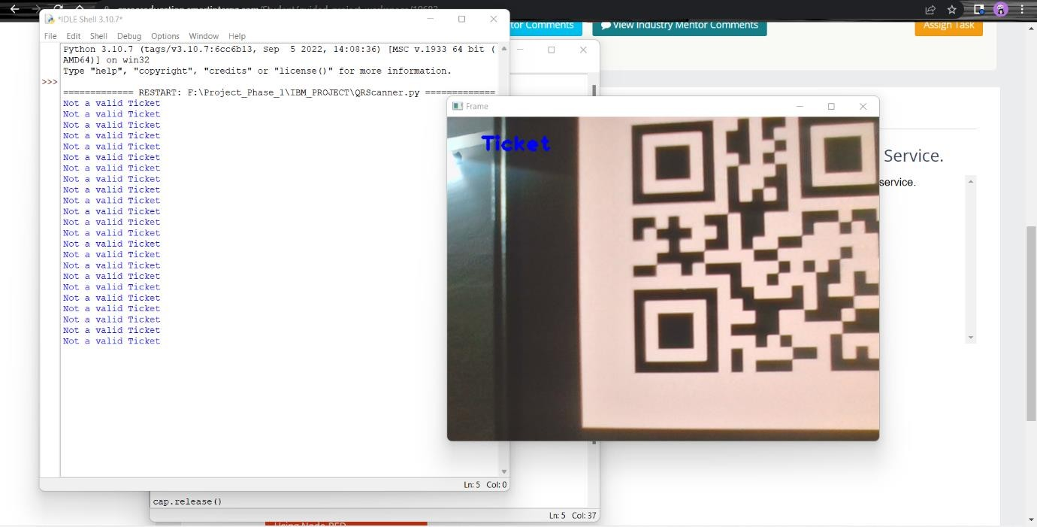

# IBMWATSONIoTPLATFORM:

* + A Node MCU device has been created through IBM Watson IoT platform ,using Kubernetes.
  + Device ID, Token, Authentication details are given and generatedautomaticallyinthePlatform.

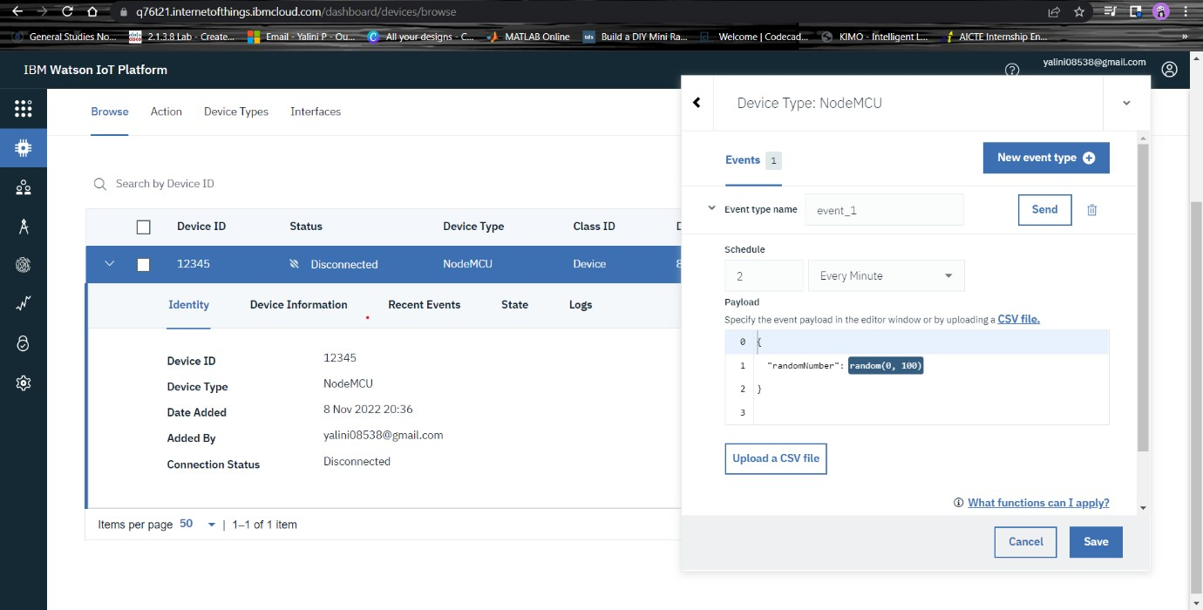

# NODERED SERVICE:

Node red has been created for smart railways and IBM Watson Iot Platform has beenconnectedtoprovideresults.

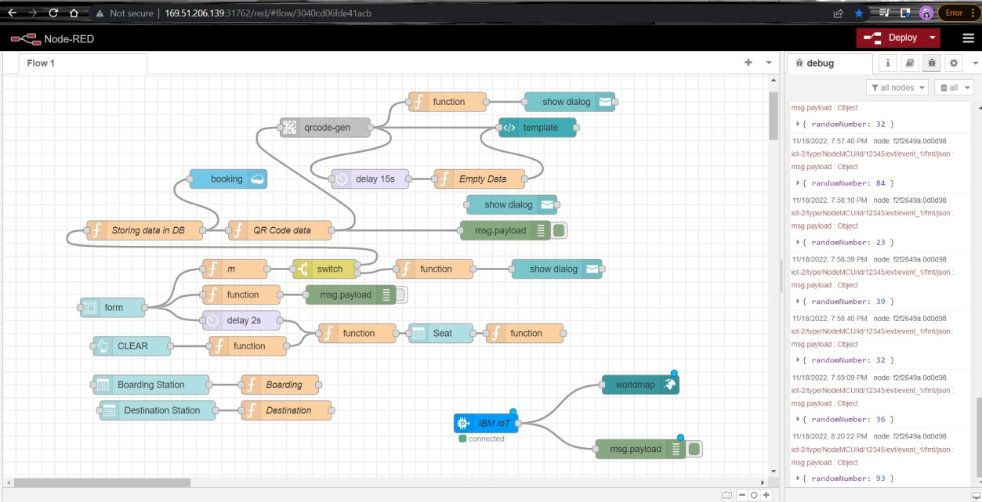

Theweb UIhasbeencreatedinaccordancewiththenoderedflow.

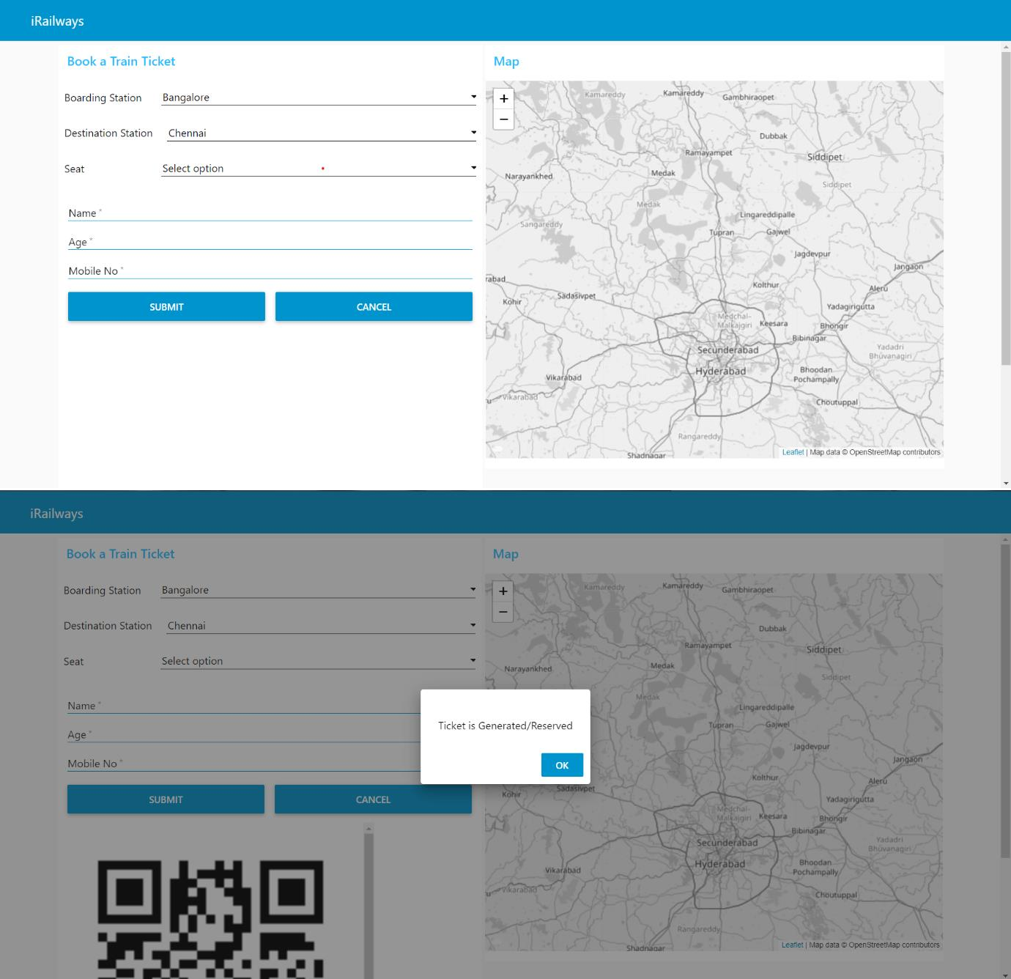

# MITAPPINVENTOR:

ANapplicationhasbeencreatedviaMITAppinventor.

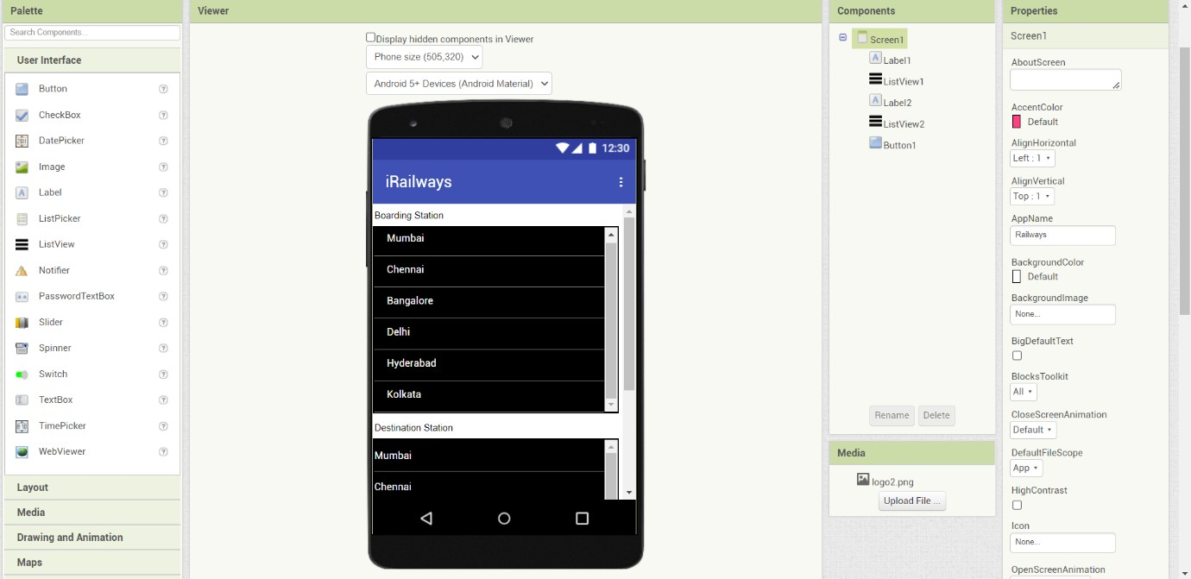

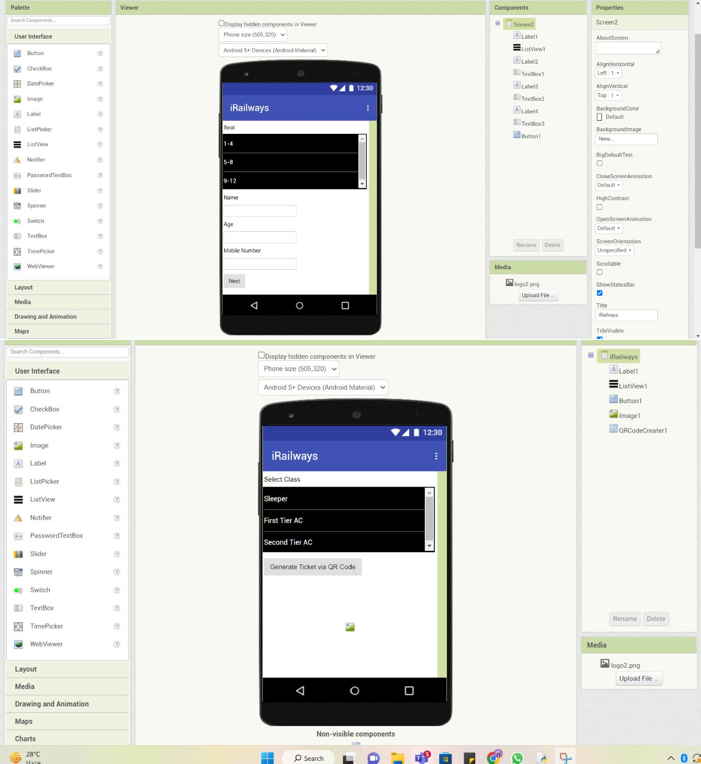

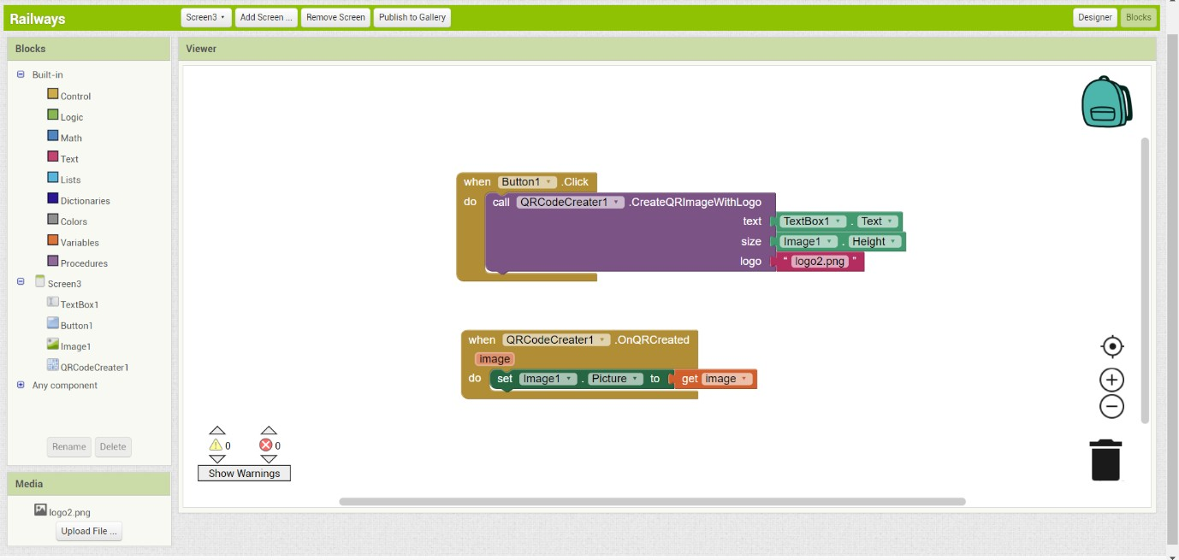

# CONCLUSION:

Thus Smart solutions for Railways has been implemented through IBM services andMIT AppInventor.Thesolutioncouldremainaseasyhandleoneforusers.